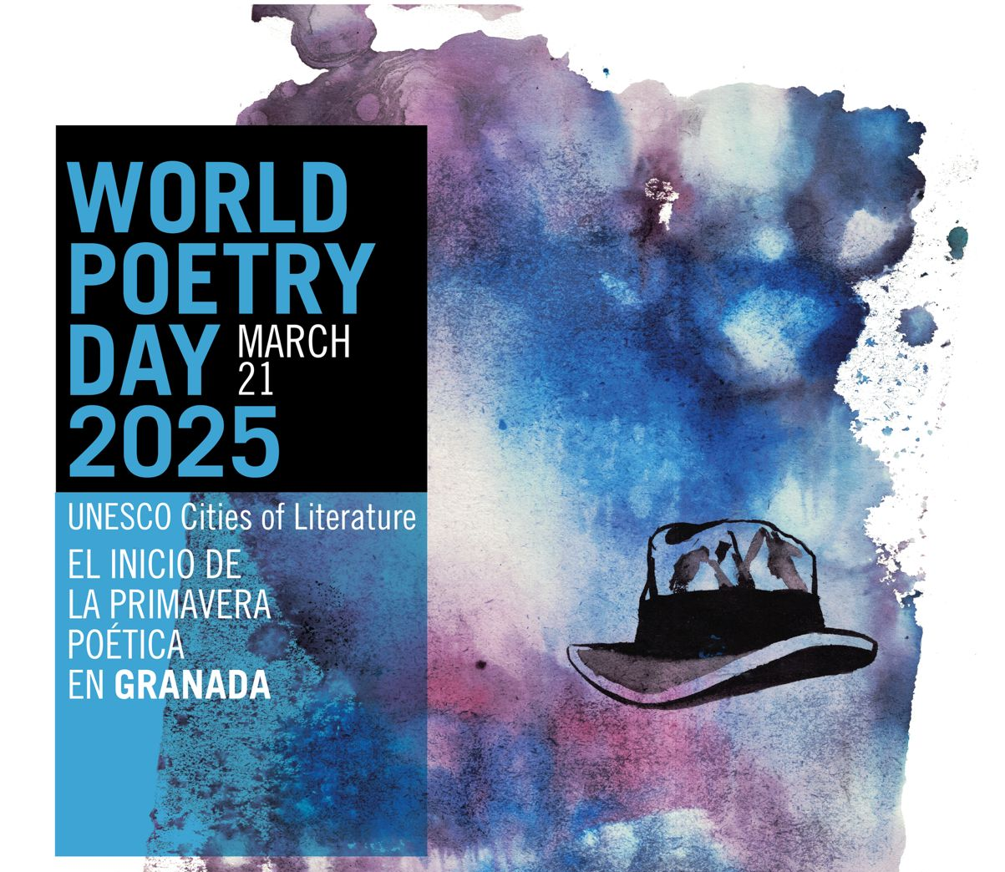

Media Release for World Poetry Day (for immediate release)

UNITED IN POETRY: UNESCO CITIES OF LITERATURE CELEBRATE WORLD POETRY DAY

Friday 21 March 2025 is World Poetry Day and UNESCO Creative Cities of Literature across the world will be celebrating the achievements of their city. 21 March was adopted by UNESCO as World Poetry Day during their 30th General Conference in Paris in 1999, and the day has since been used to champion and celebrate linguistic diversity, poetic expression and endangered languages.

The oldest surviving poem The Epic of Gilgamesh is a Mesopotamian poem that was written nearly four thousand years ago. Humans have used poetry to express their thoughts and feelings and provide a window into other cultures for centuries. With 168 poetic forms to choose from, poetry offers something for everyone regardless of their creative style and this can be seen in the variety and breadth of offerings across the UNESCO Cities of Literature network.

The theme for this year’s World Poetry Day is Poetry as a Bridge for Peace and Inclusion and in our ever divided world it offers us the opportunity to connect with one another, across countries and cultures. Granada City of Literature will be leading the celebrations for the Literature network as usual and will once again organise a large poetry reading in Granada, where the local literary community will come together for a joyful celebration of poetry.

More than seventeen Cities of Literature will be taking part, including Ljubljana. For ten consecutive years, on World Poetry Day (March 21st), Ljubljana has hosted a poetry marathon. This year, they will hold a poetry festival, which will take place between March 17th and 23rd at five locations across Ljubljana, and will be dedicated to performative poetry.

Norwich City of Literature will be running an event on Thursday 20th March with one of the UK’s most beloved writers, Wendy Cope, as she leads a 25-minute reading followed by a discussion. Melbourne will be publishing a video series of six Wheeler Centre Hot Desk fellows reading their original poetry. Tartu City of Literature will be marking World Poetry Day with a whole host of events, including a poetry book fair at Tartu Literature House, whilst if you’re in Angoulême the ‘Printemps des Poètes’ (Spring of Poets) is taking place from March 12th to 23rd.

Tukums Library will be running an initiative called ‘Gift a Poem’ which encourages visitors to share the beauty of poetry with one another. Wonju City will be taking the original work of local writers and poets and turning them into ‘Poetry Paintings’ which will then be displayed on their website.

Kuhmo will be celebrating with an open event in Kuhmo town library which is free of charge whilst Manchester will be launching their city’s new Clean and Green Strategy with Poetry in the Park at Boggart Hole Clough, where the Manchester Libraries will be handing out packets of bee friendly seeds. Meanwhile Nottingham will be celebrating World Poetry Day with a series of online videos talking to local creatives about how they got involved with poetry and what it means to them.

This year Okayama will be celebrating World Poetry Day for the first time with a ‘silent reading’ style bookclub which encourages people to read their own poetry. Milan boasts several events dedicated to poetry, offering something for everyone whilst Lyon is hosting a three-week long poetry festival. Vilnius Literary House will be hosting the final of the pupils' poetry translation competition and Heidelberg will be offering a poetry inspired church service, amongst a range of other wonderful events.

Edinburgh, the oldest City of Literature, will mark World Poetry Day with a teaser trailer made by their Edinburgh College of Art animation students, hinting at a love-letter poem for the city by Edinburgh Makar and author Michael Pedersen. Dunedin City of Literature is partnering with OAR FM on World Poetry Day for the launch in the City Library of ‘Layers of Identity’ – a creative writing podcast and book project, showcasing the diverse voices of young Dunedin writers and poets through powerful stories of identity, culture, and belonging.

NOTES TO EDITORS
World Poetry Day: World Poetry Day takes place on 21 March, and was first declared by UNESCO during its 30th General Conference in Paris in 1999, with the aim of supporting linguistic diversity through poetic expression and increasing the opportunity for endangered languages to be heard. For more information on World Poetry Day, please visit: https://en.unesco.org/commemorations/worldpoetryday

UNESCO Creative Cities Network (UCCN): Established in 2004, the UCCN aims to foster collaboration among cities that recognise creativity as a crucial element in achieving sustainable urban development. 350 cities worldwide are part of this network, united in their pursuit of a shared goal: integrating creativity and cultural industries into their local development strategies while actively cooperating on the global stage. The Network encompasses seven creative fields: Crafts and Folk Art, Design, Film, Gastronomy, Literature, Media Arts, and Music.

Fifty-three UNESCO Creative Cities of Literature from 39 countries are currently members of the Network, diligently working together to harness the transformative power of literature in fostering sustainable and inclusive societies.

For more information on the UCCN, please visit: https://en.unesco.org/creative-cities/home

To learn more about the UNESCO Creative Cities of Literature Network:
https://www.citiesoflit.com/

Enquiries to:
Granada Team
Jesús Ortega: granada@granadaciuaddeliteratura.com

UNESCO Creative Cities of Literature Network Lead:
Kjartan Már Ómarsson, Director, Reykjavik UNESCO City of Literature Kjartan.Mar.Omarsson@reykjavik.is

Follow the social media hashtag: #WorldPoetryDay

